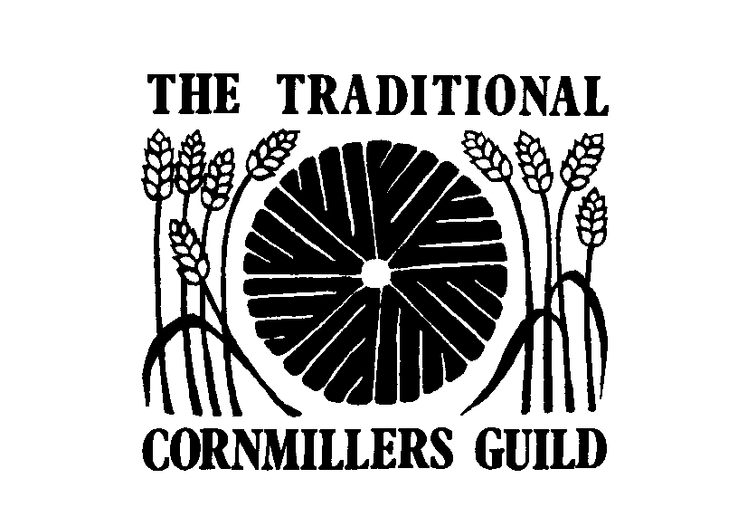

Position Paper regarding Proposed Mandatory Fortification of White Flour with
Folic Acid.

Traditional Cornmillers Guild
February 2019
Updated June 2019
Summary

For the reasons stated below, based on the current information available regarding the Government’s consultation to fortify flour with Folic Acid, the Traditional Cornmillers Guild and Mills Section of the Society for the Protection of Ancient Buildings (SPAB) as the representative organisations for traditional wind and watermills, hereby makes its case for an exemption from any regulations to fortify flour with Folic Acid for traditional wind and watermills producing less than 1,000 tonnes of flour per annum.

This exemption is sought on the grounds of the impracticality for traditional mills to add such small quantities of Folic Acid in a consistent manner given the traditional flour milling process and the consequent threat to the integrity, historic character and sustainability of these mill buildings of importance to our national heritage should there be a requirement to install machinery capable of blending Folic Acid into flour.

Introduction

On the 13th June 2019, the Government launched a 12 week consultation seeking views on the proposal to introduce mandatory fortification of flour with folic acid. This, the consultation states, is to help reduce neural tube defects (NTDs) in foetuses by raising the folate levels of women who could become pregnant. The consultation seeks views on fortifying all flours with Folic Acid, not just white flour.

The consultation concludes on the 9th September 2019.

The consultation can be found at https://www.gov.uk/government/consultations/adding-folic-acid-to-flour

The consultation invites responses to the following questions:

- Do you agree or disagree with the proposal for mandatory fortification of non-wholemeal wheat flour in the UK with folic acid to help prevent neural tube defects?
- Which products should be included?
- Are there any alternative ways of helping reduce the number of neural tube defects that you may prefer, other than our proposal for mandatory fortification of flour with folic acid?
- Are there any particular groups or individuals that might be negatively affected by mandatory fortification of flour with folic acid, or miss out on the benefits?
- How could we make sure these groups or individuals are supported or not affected negatively? Are there any businesses that might be negatively affected by mandatory fortification of flour with folic acid, or miss out on the benefits?
- How could we make sure these businesses are supported or not affected negatively?
- If the fortification of flour with folic acid is made mandatory, do you agree or disagree that there should be limits on voluntary fortification of other food products and/or supplements with folic acid?
- Impact Assessment
- What are the practical issues that need to be thought about for mandatory fortification with folic acid?
- Are there any further trade implications for industry that need to be considered?
- Are there any effects on small businesses and medium businesses that need to be considered?

What you are asked to do:
As the owner, manager, volunteer of a working mill or customer of a mill, you are strongly encouraged to respond to the consultation, in particular commenting on the questions highlighted in yellow above. You are also encouraged to raise public awareness in whatever way possible (including writing to your MP) of the potential consequences of a decision to fortify all flours with folic acid.

The document below explains the potential issues and consequences we have identified if traditional mills are required to fortify flour with folic acid and provides you with information to use in your response to the consultation.

Neither the TCMG or Mills Section have the expertise to comment on the medical evidence being used to justify the proposal to fortify flour, nor the appropriateness of using flour as a vehicle to achieve this outcome. We do, however, have the experience and authority to comment on the practicalities of traditional mills adding folic acid and the potential consequences for the integrity, historic character and sustainability of these mill buildings which represent a key part of our national heritage.

About the Traditional Cornmillers Guild (TCMG)

The Guild represents windmills and watermills producing stoneground flours using horizontal millstones, where wind or water is the primary source of power, and where the sale of flour for commercial purposes is a significant aspect of the enterprise. Most of our member mills produce less than 500 tonnes of flour per year with the majority producing between 5 and 50 tonnes per annum. Our members’ white flour output is estimated at less than 0.013% of UK output.

Member mills include some in private ownership, others owned and run by local authorities, limited companies, charities and larger estates. Most are of significant historic and heritage interest. Many produce specialist flours. The Guild does much to uphold, train and encourage good practice in the traditional craft of artisan milling, in association with the Society for Ancient Buildings (SPAB) Mills Section, and with our European colleagues.

About the Mills Section of the Society for the Protection of Ancient Buildings (SPAB)

The Mills Section of the SPAB is the UK's national organisation devoted to protecting and promoting traditional windmills and watermills. The Section campaigns to save traditional mills that retain their machinery from destruction and conversion, and provides technical advice, guidance and funding to facilitate the sympathetic repair of mills and their machinery.

Guidance on completing your responses to the Consultation:

Our guidance focuses on the questions highlighted in yellow above:

What are the practical issues that need to be thought about for mandatory fortification with folic acid?

Information you should consider (see below for further discussion / explanation):

- Lack of suitable equipment to mix folate into flour whether it is incorporated into Creta Plus (the product used to fortify white flour) or otherwise
- Mill does not have the capacity required in terms of mixing equipment, elevators, augers or hoists required to mix all flour being produced by the mil
- Listed building status of the mill and / or space available in the mill would prevent the installation of the machinery required
- Many traditional mills rely on volunteers or part-time staff, the proposals if adopted in full will present significant issues around Quality control given the small amounts of folate to be added and the consistency required.

Are there any effects on small businesses and medium businesses that need to be considered?

- The cost of purchasing, installing machinery required and the consequent training would be prohibitive to the financial viability of the mill, requiring the mill to install it would potentially lead to the mill ceasing to produce flour putting at risk the future sustainability of the mill as an historic (listed) building
- Flour sales form the majority of income for the mill, removing it would put the very future of the mill at risk
- The costs of manufacturing and installing a suitable mixing vessel, associated lifting and storage equipment would be in excess of £10,000.00 which represents x%* of our yearly income from flour sales, even assuming there was suitable space and the listing constraints for the mill permitted it
- Adding additional processes into the flour production cycle would significantly increase costs in terms of labour, putting at further risk the commercial viability of producing flour in traditional mills. Traditional milling of flour is a highly labour intensive, low margin business activity, even acknowledging the premium price charged for artisan stoneground flours when compared to roller milled flour.
- The majority of working traditional mills rely on volunteers and many are run on a not-for-profit basis.
* - calculate the % that applies to your mill

See below for more information and guidance

Background

The TCMG and Mills Section have been aware of the potential issues for traditional mills surrounding the fortification of flour with folic acid for some years. Both organisations made representation to the DEFRA led consultation in 2009 / 2010, meeting with Dr Michelle McQuillan and colleagues at the time to raise our concerns along with representations to the then Agriculture Minister, James Paice MP.

With the renewed pressure to move the issue forward from the Scientific Advisory Committee on Nutrition (SACN) in 2018, the Guild agreed at the TCMG Autumn Meeting in November 2018 that a survey of members should be carried out to build data in order to understand the potential impact of any future requirement to add folic acid to flour. The survey was designed to establish the quantities and types of flours currently being milled, including white flour, along with details of the processes mills use including mixing methods and any potential difficulties that might prevent effective implementation of fortification.

Based on that survey, further discussion with members and consultation with the SPAB Mills Section, our joint position is as follows:

Our Position

- We support the intention to minimise any risk of neural tube defects.
- We understand the rationale behind the proposal to fortify flour, as a foodstuff consumed by a majority of people, and therefore most likely to reach at-risk individuals.
- We understand that the dosage of Folic Acid is a potential factor to ensure the well-being and safety of all individuals consuming fortified flours.
- Traditional milling uses horizontal millstones, a very different process to modern roller milling (see diagrams in the Appendices below). The majority of traditional wind and watermills have no mixing or blending equipment and a significant number of working traditional mills produce wholemeal flours only.
- The basic processes and technology used in traditional milling are inappropriate and impractical for highly accurate and consistent dosage in the very small amounts that are likely to be proposed.
- This is because the traditional mills that produce unbleached white flour use simple, basic mixing arrangements to add Creta Plus, (typically small batches of around 25 kilos) or add Creta Plus into the flour sieving process at the feed bin to the flour dress (see diagrams below).
- Traditional mills do not have the capacity required in terms of mixing equipment, elevators, augers or hoists required to add folate to all flours.
- Adding additional processes into the flour production cycle would significantly increase costs in terms of labour, putting at risk the commercial viability of producing flour in traditional mills. Traditional milling of flour is a highly labour intensive, low margin business activity, even acknowledging the premium price charged for artisan stoneground flours when compared to roller milled flour.
- The TCMG survey confirmed that 62% of the mills represented by the Guild are listed Grade 2* and above which significantly restricts their ability to change their internal layout without listed building consent. Only three of the Guild’s mills are not listed, as such all have significant Historic Interest. Thus, any requirement to install sophisticated mixing equipment would a) compromise their integrity and b) be difficult to achieve given the Listing issues outlined above.
- Limited space for mixing machinery was cited as another potential issue for some mills.
- Traditional mills unbleached white flour output is estimated at less than 0.013% of UK output.
- Given the socio-economic make-up of the great majority of traditional mill customers, the statistical likelihood of traditionally milled flours being used by identified at-risk people within the UK is likely to be extremely small.
- Additional cost of equipment, testing of flours, time for training of volunteers, and administration could jeopardise the viability, and potential sustainability of member mills.
- Traditional milling, mills and their products, and the skills associated with running and maintaining them, are therefore considered inappropriate vehicles for delivering the proposal.

Therefore traditional mills would seek exemption from the requirement to fortify, on the grounds of impracticality, potential risk to consumer health, and threat to the integrity, historic character and sustainability of buildings of importance to the national heritage.

If traditional mills were not exempted, there is a significant risk that the future viability of traditional mills would be put at risk, thus endangering the future of a significant number of the nation’s listed buildings which rely on income from flour production to secure their futures.

Our recommendations:

- That, if flour is the preferred vehicle for fortification, whether white flour or all flours, traditional mills producing less than 1,000 tonnes of flour be exempt from the requirement to fortify.

- That all wholemeal and specialist flours and grains be exempt from the requirement to fortify.

- That any flours exempted from adding Folic Acid be clearly labelled.

Working Traditional Mills not part of the TCMG

In addition to TCMG members, there are approximately 60 additional traditional wind and watermills producing flour in the UK. A reasonable estimate of their current production is considered to be between 250 and 300 tonnes of flour per annum (total combined output of the 60 mills). Based on the proportions of wholemeal and white flours of Guild members, we estimate their white flour production to be around 95 tonnes per annum.

Report compiled by Nick Jones, Hon Secretary and past Chairman, TCMG
and Jonathan Cook, past Chairman, TCMG, and SPAB Mills Section.

Appendices follow:

1. Diagram to Illustrate the Traditional Milling Process using horizontal millstones.
2. Diagram to illustrate white flour process in a traditional mill.

Information & Advice

Please contact:

Sophie Martin 0207 456 0909 sophie@spab.org.uk
Jonathan Cook 07796 696091 jon@fostersmill.co.uk

Appendix 1: Diagrams to Illustrate the Traditional Milling Process

Whilst the form of power is different between wind and watermills, the method of flour production is identical. The diagram below shows the layout of mill machinery in a traditional watermill – as can be found in many of the UK’s working watermills. The process is then described in more detail in the drawings that follow:

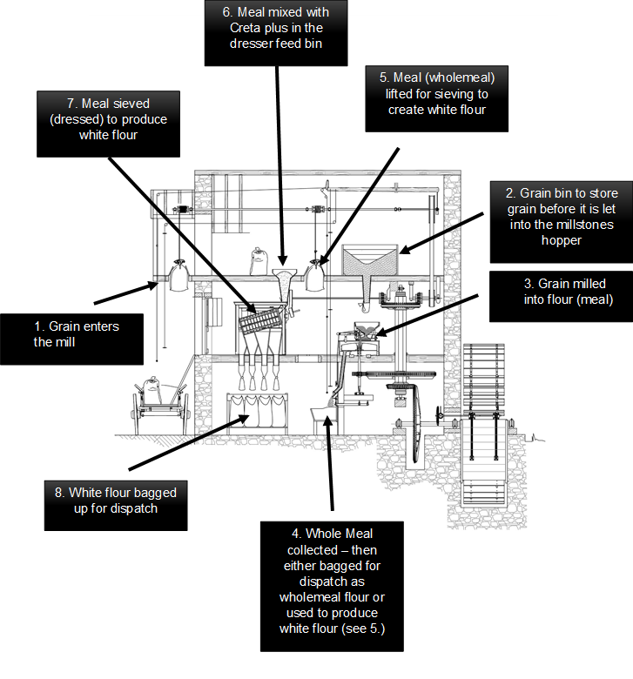

Note: Creta Plus is the trade name for the powder substance that contains the active ingredients calcium, vitamins and iron, statutory additions to flour required by the Bread & Flour Regulations 1998.

Appendix 2: White Flour Production Process

The diagram below shows the white flour production process in greater detail. As described above, follow the process from 1. As can be seen, most traditional mills do not possess equipment to mix and blend additives to flours in any consistent way. Creta Plus, the mix of additives required to ensure white flour contains the levels of vitamins and minerals required to meet the standards set out in the Bread & Flour Regulations 1998 is typically added to the meal in the dresser feed bin. Whilst this ensures white flour meets the Regulations, it is not an exact method and most mills cannot guarantee an exact and even distribution of Creta Plus in white flour. This is not a significant issue given the current constituent elements of Creta Plus, but if folic acid is to be added, our understanding is that over dosing will be a major issue and one with a potential impact to human health.
Meal mixed with Creta Plus in the dresser feed bin
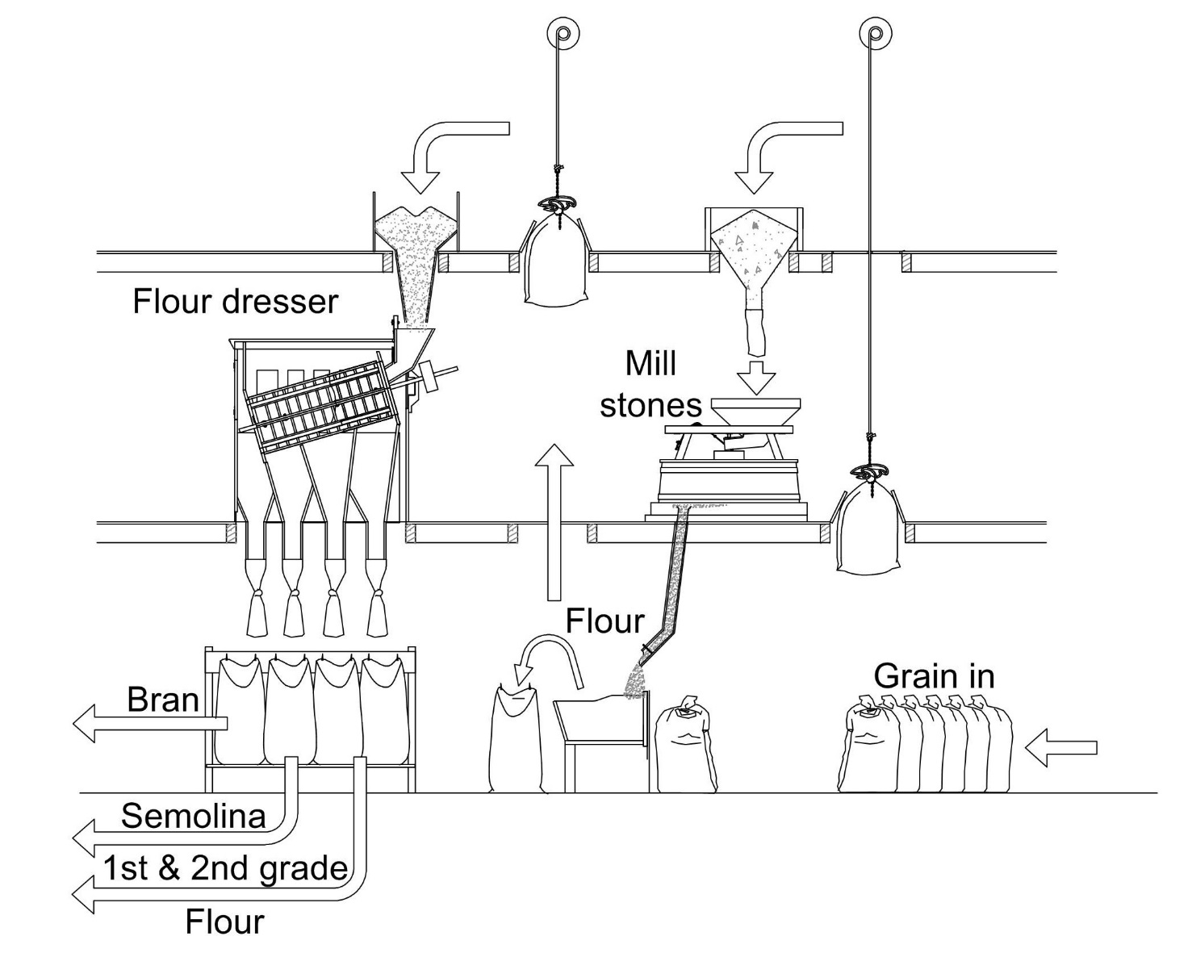

Grain enters the mill

White flour bagged up for dispatch

Creta Plus is the trade name for the powder substance that contains the active ingredients calcium, vitamins and iron, statutory additions to flour required by the Bread & Flour Regulations 1998.

